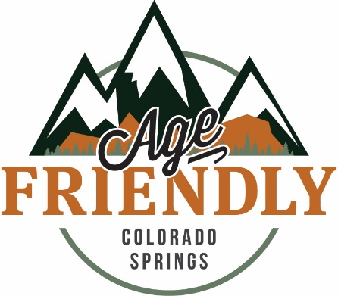

Get Involved!
Outdoor Spaces
Identify and map easiest, most accessible trails. As part of a larger effort to eventually create an app/map that rates local trails based on difficulty and notes challenges for older adults and people with disabilities. The first step can be put together by a committee of various-abled people and seniors to establish a standard metric for evaluating trails. Innovations in Aging can organize the meetings and provide information from other communities and the standards of universal design to help with the process. Once a metric is created, volunteer hikers can be recruited to walk/wheel our local trails and evaluate them, as well as note whether they are appropriate for wheelchairs, walkers, canes, etc. The resulting information about Age Friendly trails will be available on the IIAC website, and made available to Parks and Rec and TOSC to use as they see fit.
Transportation
Discuss Walk Your City Initiative, a program that encourages people to travel on foot by providing simple signs that give walking times to key destinations and have QR codes that can be scanned for walking directions. Determine where in Colorado Springs signs could make the most impact and contribute the most to quality of life and highlight businesses, attractions, and places that should be signed. Innovations in Aging can advise and facilitate.
Housing
In other cities, alternative dwelling units (ADUs) have contributed to solving affordable housing crises. In Colorado Springs, we are interested in exploring how ‘granny flats’ and other ADUs can contribute and promoting awareness of them, as well as advocating for modification of zoning codes as necessary. Innovations in Aging will support a citizen group working on this exploration and advocacy and coordinate efforts with the Commission on Aging.
Community Support and Health Services
We are focused on encouraging local implementation of the Conversation Project, a program dedicated to getting people talking about end of life care and their wishes with loved ones. Join the effort, start discussion groups, and host Jeffersonian dinners in your neighborhoods and communities. Innovations in Aging will assist with coordinating, organizing, planning, and educating.
Respect and Social Inclusion
Intergenerational enrichment opportunities are a priority for many different groups in Colorado Springs. Innovations in Aging would like to establish a citizen focus group to brainstorm ideas for intergenerational activities/interactions, put together a wish list, and discuss partners/steps for implementation.

Contact us!
Innovations in Aging Collaborative

Web: www.innovationsinaging.org
Email: claire@innovationsinaging.org
OR agefriendly@innovationsinaging.org
Phone: (719) 602-3815

