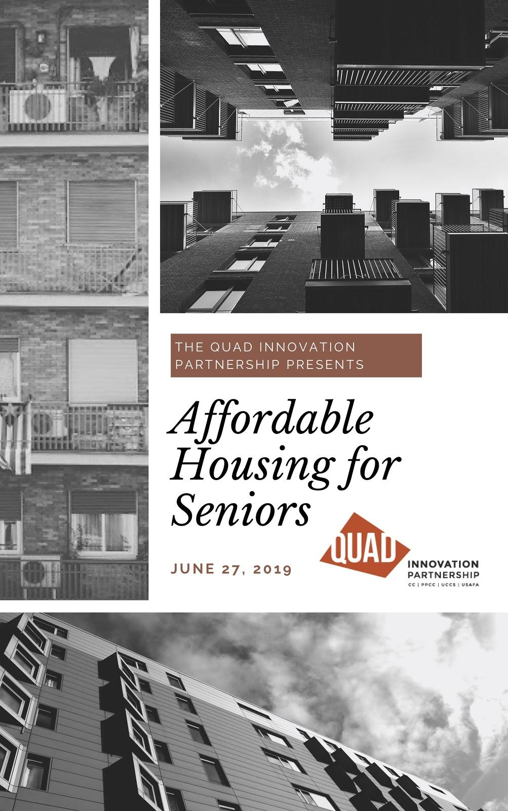

Executive Summary

The exacerbating affordable housing crisis continues to affect the citizens of Colorado Springs. Although this problem affects many types of residents, senior citizens bear the brunt of this crisis. The average apartment rent in 2018 measures at $1,230.00 a month for a two bedroom in Colorado Springs, while seniors who rely on fixed income from Social Security benefits average an annual income of only $16,900.00. If a senior on Social Security were to live in a market rate apartment, they would spend 87 percent of their annual income on housing alone. Of course, most seniors have access to resources beyond Social Security and some are able to afford to live in market-rate housing and assisted living comfortably. However, many seniors in the Colorado Springs area struggle to find housing at a comfortable price point. In the Front Range Sub-Area, it is estimated that there is a demand for 2,439 affordable living homes. The problem isn’t only housing. According to the Pikes Peak Area Council of Governments Area Agency on Aging’s (PPACG) 2018 report and the 2020-2023 4-year plan, nearly one-quarter of senior’s struggle to access necessities of everyday life such as access to food, transportation, and housing. This illustrates that the problem we are facing is bigger than only housing; it is a problem of the cost of a high quality of life.

There are many valuable components to solving the problem of affordable housing for seniors, but this report focuses on improving quality of life. This report provides a set of concepts meant to inform future affordable housing developments to maximize quality of life for residents. It is meant as a follow up to the report produced in May, 2019 by the Quad studying housing affordability for seniors specifically.

This report summarizes needs of seniors residents, details capacity and programs at area nonprofit service providers and outlines a set of concepts developed from this information to maximize quality of life in an affordable way including:
- Leveraging a dense, campus-like environment to centralize the provision of services that contribute to quality of life, including:
- Developing a community-centric shopping center near the senior apartments as a revenue source to support service provision.
Working towards a swipe card system to streamline seniors’ access to local businesses and essential services.
Table of Contents
Executive Summary 0
Project Overview 2
The Needs of Seniors 2
Food 3
Health 3
Transportation 5
Example Service Partnership 5
Silver Key 5
Potential Partnerships 7
Concept Solutions 9
Campus Environment 9
Case Manager/Front Desk 9
Seniors Helping Seniors 10
The “U” 10
Swipe Cards 12
Conclusion 13

Project Overview
This report is the second phase of a study to meaningfully advance the development of an affordable housing complex for seniors for Innovations in Aging, a local nonprofit.

Phase 1, conducted during the Spring, 2019 academic semester, conceptualized an operating model for an affordable housing unit for older adults in the Colorado Springs metro area and identified a range of essential information, strategies, and examples to support development. The student team assessed zoning laws, policy, tax credits, alternate income stream options, construction method and cost optimization, land opportunities, and intergenerational living concepts. They validated existing tax credits as the most viable method to maximize the construction of housing and recommended a work-live housing model where residents work in the development or in the ancillary businesses to support quality of life-related service provision.

This Phase, conducted via the Quad’s annual Summer Intensive focused on expanding understanding of quality of life within a senior living context. The Quad team extracted information from the previous Quad report, the PPACG AAA 2018 Report, and the PPACG AAA 2020-2023 Area Plan to establish a comprehensive list of senior needs and services available in the area. These services were chosen to try to meet the foundational needs of human beings defined by Maslow’s Hierarchy of Needs.

The Needs of Seniors
The seniors targeted by this study are in lower income brackets, meaning their unmet needs may be more significant than higher income groups. The Pikes Peak Area Council of Governments (PPACG) produces significant research annually on senior needs locally; most information in this section has been extracted from two of their reports.

According to Colorado Housing and Finance Authority (CHFA 2018 Affordable Housing Tax Credit report, the average rent in Colorado increased by 8.7 percent annually from 2014 to 2018 to $1230 per month for a two bedroom. While, wage growth increased only 3 percent. The result is a lack of affordable units for the low-income population regardless of age. Many people in the 30-80% average median income (AMI) (15th-40th income percentile) must use a large percentage of their paycheck on housing, which leaves them unable to afford other quality of life goods and services such as healthy food, quality healthcare, and exercise.

For seniors specifically food, transportation, housing, and healthcare are the top issues in the Colorado Springs area. The PPACG Area Agency on Aging (AAA) 2018 Report that details the lived-experience of area senior residents identifies that quality food and transportation are ranked as the least accessible locally, compared to other communities in the United States. The figure below compares seniors’ ratings of the Colorado Springs community in 2010 and 2018.

Figure 1: Senior Community Quality Ratings, 2010 and 2018
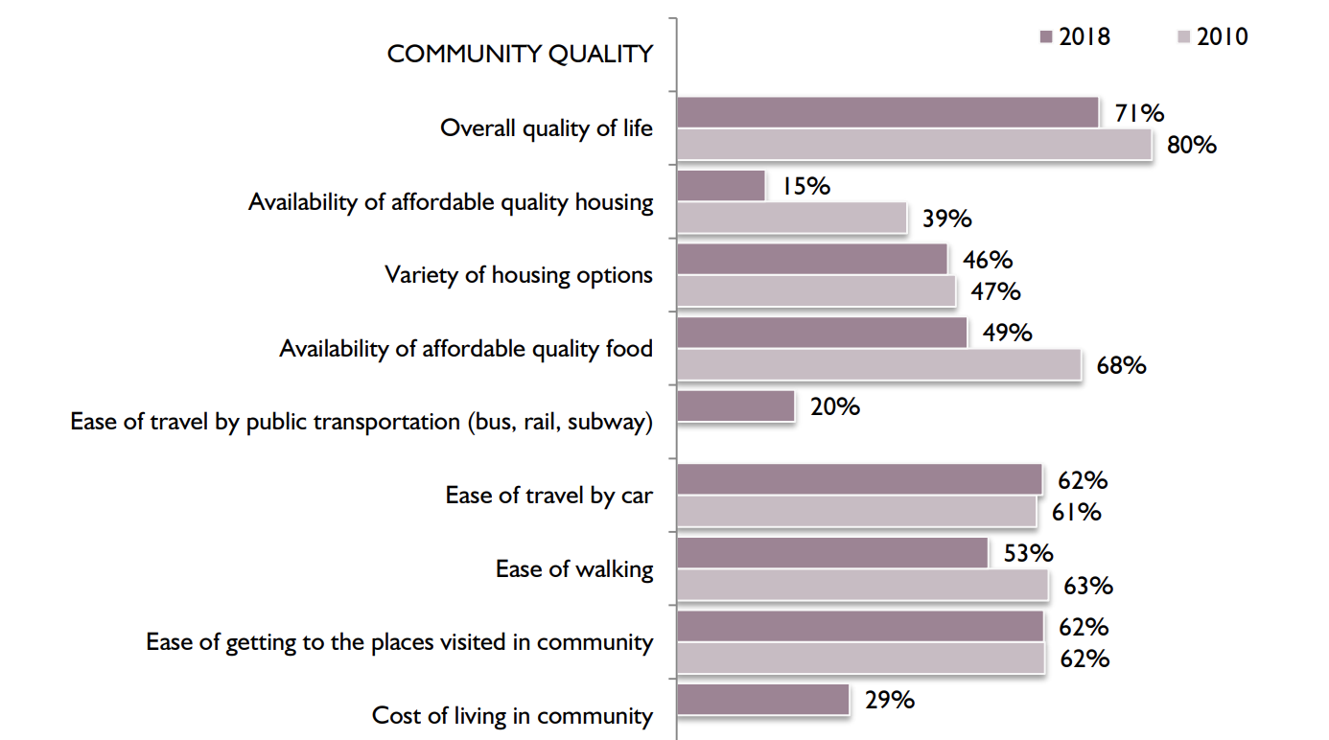
Percent rating positively (e.g. excellent or good)

Food
12% of seniors reported not having access to a reliable food source. Nonprofit organizations are at work trying to ensure no senior in the Colorado Springs area goes hungry, but despite their commendable efforts, the problem still exists.

The PPACG report identified food as a key future concern for seniors in the Colorado Springs area, meaning seniors who currently have access to food are worried about continuing to be able to provide food for themselves.

Any senior living development that cares about providing a high quality of life for seniors must find ways to provide healthy food. Partnering with local food providers, ranging from a pantry like Care and Share to a prepared meals provider like Silver Key, could create accessibility for seniors to access quality food at affordable housing facilities. Not only with these partnerships allow for the correct dietary consumption to be implemented, but it will minimize associated costs by leveraging existing organizational infrastructure.

Health
The greatest risk for the aging populations is the decline in mental and physical health. Seniors in the Pikes Peak Region report problems related to heavy or intense housework (58%), maintaining their yards (42%) and staying physically fit (59%). Additionally, one in three seniors experience difficulties performing everyday activities, such as walking, eating, and preparing meals.

The availability of preventative healthcare for seniors is rated lower than other communities in the country. Seniors in Colorado Springs also struggle with mental and emotional stressors ranging from feeling bored (44%) to depression (42%) to dealing with the loss of a loved one (42%) to even difficulties figuring out which medications to take and when (13%).

These statistics show that providing a quality of life that extends to mental and physical health is vitally important. Incorporating activities that seniors can thrive in is not always intuitive. Incorporating the appropriate activities will provide stimulation, aid to emotional distress, and community involvement. Partnering with local agencies can likely provide these essential health services affordably and reliably.

Background information: Medicare
Over sixty million seniors are enrolled in Medicare across America, and over 520,000 are Colorado citizens.

Medicare is a national health insurance program that serves seniors 65 years and older. To qualify for certain Medicare Part A benefits, an individual has to have worked a total of 40 quarters (10 years). If this requirement is not met, they can access Part A by paying a premium of $437 if they have worked less than 30 quarters and $270 if they have worked 30-39 quarters. Part B, which covers doctors’ services, and Part D, which covers prescription medication, do not require any specific amount of quarters worked.

Background information: Medicaid
More than twelve million seniors are dually enrolled in both Medicaid and Medicare. Medicaid serves low income individuals, and children.

Around 40% of seniors are considered low income, according to the US Census. Adults 65 years and older represent 11% of 72.5 million Americans covered by Medicaid.

Medicaid is required by law to cover non-emergency medical transportation through their non-emergency medical transportation (NEMT) program. Medical providers are responsible for abiding by the specific rules in their state.

Colorado’s NEMT services are provided by State Designated Entities (SDE). The three types of SDEs include:
- County Departments of Human Services
- The three Multi-county collaboratives:
  - Northwest Colorado Council of Governments (Mountain Ride Transportation Resource Center)
  - Northeast Colorado Transit Authority (County Express)
  - San Luis Valley Multi-County Collaborative (Red Willows)

- State contracted NEMT broker Veyo

Transportation

Seniors are generally safe drivers compared to other age groups, but a car crash is more likely to be fatal for people 65 and up. According to a 2016 CDC report, there are almost 42 million licensed drivers ages 65 and older, a 56 percent increase from 1999. In 2016, there were over 7,400 older adults killed and over 290,000 injured in motor vehicle crash injuries in Colorado.

Furthermore, seniors currently are outliving their ability to drive safely by an average of 7 to 10 years. While this is a remarkable testament to modern medicine and life spans, it does pose a challenge to quality of life. In Colorado Springs, 31% of seniors experience problems finding safe and affordable transportation, which can compound existing challenges and also contribute to social isolation and worsened mental health.

It is expected that some of the tenants at a senior complex will have access to their own transportation, but not every senior will. Using existing resources to aid transportation of seniors will be vital for the social engagement of seniors.

Example Service Partnership
Partnerships offer opportunities to leverage existing infrastructure to meet needs. This is an example of the logistical considerations required to feed seniors via Silver Key’s Connections Café program using the bus for transportation. Additional potential partner agencies are listed in the next section. Any partnership will likely require this level of logistical consideration to implement.

Mountain Metropolitan Transit Bus System
The Mountain Metropolitan Transit fare for ages 60+ is only .85 cents, compared to $1.75 for other ages. Seniors can also get a special 20-ride ticket for $16.00 which averages out to .80 cents per ride.

The PPACG 2018 report shows that public transportation use among seniors has decreased from 17% in 2010 to 10% in 2018. The report also shows that only 4% of older adults used senior car service or shuttle in the past 12 months. The bus routes often require that seniors walk long distances to their destination, which can be a significant obstacle for the elderly community.

Silver Key
Silver Key Connections Café and Meals and Wheels are the two main food services available to elders in Colorado Springs.

- Connections Café:
  - Offers lunch Monday-Friday to people 60 years and older and their spouses.
  - Seniors under 60 can use their services if they have a disability and live in a senior housing facility.
  - Diners must make a reservation by 2 pm the day before dining by phone or online.
  - They ask for a suggested donation of $2.25 but will not turn anyone away who isn’t able to pay.
  - The guest fee for a non-eligible diner is $6.

- Meals on Wheels:
  - Delivers three lunches per week from a menu of options delivered directly to the senior’s apartment.
  - Recipients must be 60 years or older.
  - Must call for a client assessment through Silver Key before joining the delivery program.
  - Cost per meal is $4.50. The program accepts cash, checks and credit cards, as well as SNAP food stamps.
  - In Colorado Springs, local community donations may be available to partially fund meals.

Seniors can travel to and from Connections Café locations using Silver Key transportation or the Colorado Springs bus system.
- Silver Key Transportation:
  - Not currently accepting new clients.
  - If the senior is already registered, they suggest reserving a ride one week out, although sometimes they’re booked even that far out.
  - They receive over 200 calls per day and often must place the seniors on hold.
  - Drivers can arrive anywhere from 15 minutes early to 15 minutes late.
  - Seniors can cancel up to one hour before.
  - Three no-shows or late cancellations in a 60-day period will result in a two-week suspension.
  - Ride times vary depending on their schedule, since they are constantly picking up dropping off seniors.
  - They assist the seniors in getting to and from the van safely.

Using the bus system to get to and from Connections Café meals can take up to hours of a senior’s day and may be difficult to navigate if they are disabled in any way. The bus route round trip times to Connections Cafe locations are illustrated in Table 1. The bus ride times, walk times, and total round-trip times are shown in minutes.

See next page.

Table 1: Bus Routes to Connections Café Locations from Citadel Mall Bus Stop

Connections Café Locations | Bus Ride (One Way) | Transfers | Walk from Bus Stop (Min) | Round Trip  (Min) | Serving Time
S. Murray Blvd. Silver Key Connections Café | 20 | 0 | 4 | 48 | 11:45-12:30 weekdays
Fountain Valley Senior Center | 31 | 1 | 9 | 80 | 11:45-12:30 weekdays
Pikes Peak Towers | 33 | 1 | 0 | 66 | 12:00-12:30 weekdays
Villa Santa Maria | 40 | 1 | 7 | 94 | 11:30-11:45 Monday and Wednesday

Bussing to and from healthcare locations can be similarly difficult, as illustrated in Table 2 (bus ride times, walk times, and round-trip times are in minutes).

Table 2: Bus Routes to Healthcare from Citadel Mall Bus Stop

Healthcare | Bus Ride (One Way) | Transfers | Walk from Bus Stop | Round Trip
UCHealth Memorial Hospital Central | 7 | 0 | 4 | 22
Encompass Health Rehabilitation | 13 | 0 | 0 | 26
Penrose Hospital | 34 | 1 | 6 | 80
Medical Centre Pt. | 17 | 1 | 5 | 44
Davita Medical Group's East Campus | 55 | 0 | 15 | 140
Rocky Mountain Healthcare Services | 50 | 1 | 0 | 100

Potential Partnerships
Below is a list of potential partners in the Pikes Peak Region.

- UCCS Aging Center:
  - The aging center focuses on enhancing the quality of life for older adults and their families through excellence in psychological training, services, research, and integrated care partnerships.
- UCCS Aging Center provides comprehensive psychological and neuropsychological assessment and treatment services to individuals 55+ as well as their families.”

- Copper Cultural Office:
  - Copper Cultural Office connects residents and visitors with arts and culture to enrich the Pikes Peak region.
  - The seniors living in the apartment complex would be able to reach out to the copper cultural office to obtain information regarding how they can get connected within the arts community.

- Silver Key:
  - Silver Key services include case management, power of attorney, food pantry, senior outreach service, connections cafe, home delivered meals, and ride transportation service.
  - Although Silver Keys transportation service is currently full, the apartment complex can utilize the concept by providing our own bus or vehicle.

- Pikes Peak Area Council of Governments Area Agency on Aging:
  - Provides accurate information and resources at their Senior Information and Assistance Center.
  - Internet-based network of care helps seniors, adults with disabilities, and caretakers.
  - Organizes local resources into a “Yellow Book” to help seniors access information on area services.
  - Case managers help seniors navigate Medicare benefits.
  - Ombudsman program protects seniors against abuse, neglect, and exploitation.
  - Caregiver Support Center helps caregivers manage responsibilities while taking care of themselves.

- Association of American Retired Persons (AARP):
  - This organization hosts job, health, and financial workshops for local seniors.
  - AARP’s membership program includes insurance coverage for healthcare, vehicles, housing and more.

- Fountain Valley Senior Center:
  - Transportation program helps seniors in wheelchairs access needs and reduce isolation,
  - Nutrition program partners with Silver Key Connections Cafe to provide lunch on weekdays, as well as coffee and donuts on weekday mornings.
  - Rural Area Meal Program (RAMP) provides frozen or shelf-stable meals to home-bound seniors.
  - Fitness and Wellness Programs offer exercise classes such as fitness walking, seated yoga, Tai Chi, Chi King, and modern interpretive dance and line dancing.
  - Recreation and Wellness programs include indoor and outdoor activities, arts and crafts, painting, and coordinated day trips to theaters and local attractions.
  - Information and Referrals program offers point of contact for services in the community.
  - Kittie Paster Thrift Shoppe sells donated items.
  - The apartment complex can utilize concepts from the Fountain Valley Senior Center, and incorporate them into their own Senior Center.

Concept Solutions
This section details the three main concepts previously mentioned as well as others with likely positive impacts on quality of life.

Campus Environment

Many affordable housing developments are limited to a single building or residence hall. By concentrating multiple residences in one geographic area - similar to a college campus - offers economies of scale and key advantages for improving quality of life.

Perhaps unexpectedly at first glance, seniors struggle with many of the same problems as college students. They are in the midst of a lot of change and experience isolation and depression at greater rates than other age groups. Allowing seniors access to similar resources to those available on college campuses may help to alleviate some of these shared issues. Two specific elements of a campus environment that will have demonstrable impact on quality of life are a “Resident Advisor”-like position in each residence hall and physical design to facilitate connection and socialization, much like a college dorm.

A Resident Assistance (RA) program in the senior apartment halls could help to alleviate some of the problems that seniors face daily. Similar to Resident Advisors on college campuses, this RA would encourage community within the complex and assist seniors with problems such as access to food and exercise. They could schedule intentional programs, proactively reach out to residents and otherwise build community. Again, similar to an undergraduate campus, the position could be filled a capable senior resident in the complex and has a wealth of knowledge about where they live and the surrounding area.

Intentional building design can further a feeling of community. The location of buildings, their visual and physical aesthetic, and intentional gathering spaces and community spaces can all encourage social interactions among residents. Giving residential areas a sense of identity - different names, “brands”, and gathering spaces - can also contribute to a sense of connection and belonging among the residents. Colleges and universities often have themed housing or rivalries between dorms that deepen the students’ sense of place (think: houses in the Harry Potter novels). The Quad team hopes that bringing this campus-like layout can help the seniors feel at home.

Case Manager/Front Desk
The PPACG 2018 Report found that only 4/10 older adults gave “excellent” or “good” ratings to the availability of information in the Pikes Peak Region around how to meet their needs. Hiring a dedicated case manager or front desk concierge that specializes in navigating senior resources would increase the quality of life for residents, because it would help address this problem internally. This employee would be an outside hire, meaning they are not a tenant in the complex. The service desk would be located in the lobby of the complex.

Case Manager Responsibilities include:
- Scheduling and calling rides for residents
- Making doctor's appointments for residents
- Providing residents info about the area and surrounding areas
- Building a relationship with residents
- Directing visitors

Seniors Helping Seniors

Current trends indicate seniors are staying in the workforce longer and longer. In popular terms, the term “retirement” has been increasingly replaced by “restylement” – moving from a full time, intense career to a less intense – but still serious – working situation more consistent with an individual’s desired lifestyle. Evidence supports this: there are far more seniors 65 and older in the workplace than three decades ago. According to a study by Senior Living, between 2011 to 2016 there was a 35 percent increase in seniors working. This group is projected to be the fastest growing segment in the workforce all the way through 2024. It is also reportedly difficult for many seniors looking for work to find suitable positions. Leveraging seniors willingness – and frequent desire - to continue productive work as they age poses a viable opportunity to pay tenants capable of working to provide services to other tenants in need.

For example, residents capable of driving can provide transportation to those who can’t. This could both increase the income of the drivers (or offset residence costs) while alleviating transportation access issues for those who can’t drive. Driving to meals and appointments together could also deepen the sense of community within the apartment complex, further reducing social isolation and depression. Of course, drivers would need to pass some kind of safety exam prior to taking on any official duties.

Another opportunity could relate to gardening and landscaping around the property. Many people including seniors love to garden; therefore, this work would provide them some spare income along with creating an activity they enjoy and reducing overhead for the complex.

Some formal jobs of this type could lead to the complication of hiring/firing residents for performance issues, which might get in the way of residents feeling comfortable in their living place. Colleges and universities routinely address this, so this challenge seems surmountable.

The “U”

Funding service provision, nonprofit partnerships and anything beyond the walls and roofs of the residences themselves is an unsolved challenge in the world of affordable housing. Though tax credits can subsidize residential building costs and Medicare/Medicaid sometimes can support healthcare, the components of a truly high quality of life do cost money. Building a community-oriented, campus-like shopping center right beside the apartments could provide revenue to support quality of life programs while also providing unique benefits of its own.

Ideal tenants include a mix of walkable retail, food, nightlife and other services ranging from fitness to hair care to medical care. Urgent Care, in particular, could be a viable tenant in a location near the Citadel Mall as there are none nearby.
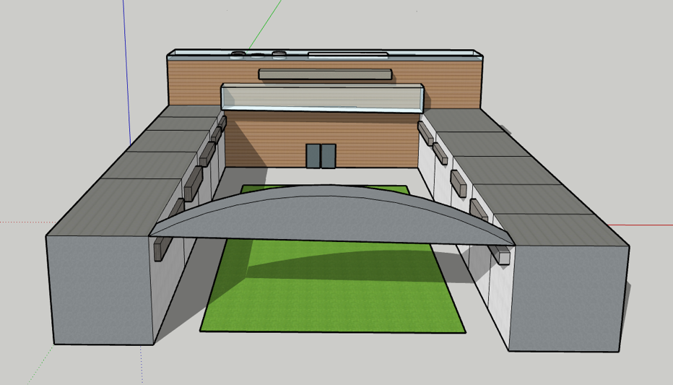
This mix of tenants would both provide accessible services to meet the needs of senior residents and also draw in younger members of the Colorado Springs community – increasing intergenerational connectivity – and also offer revenue opportunities to support quality of life for residents.

To maximize social interactions, the center of the shopping center would have a lawn which could be used for yard games, sports game viewing parties, movie viewings, live music, and other popular events. This concept is similar to Container Park in Las Vegas.
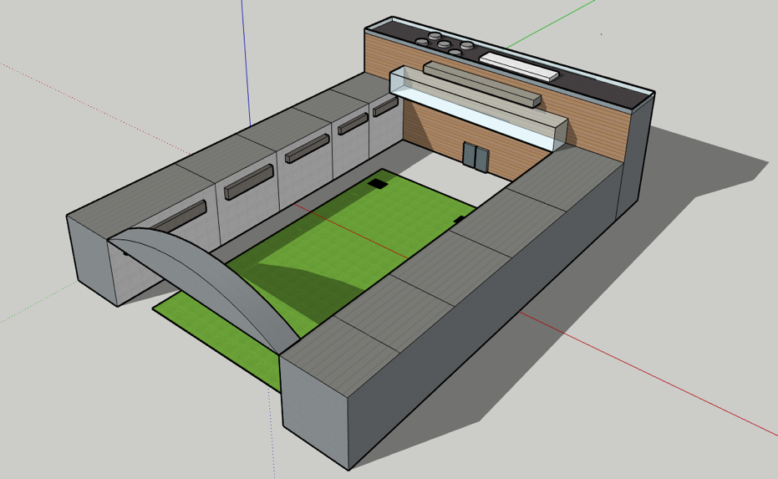
Through interviews with young adults from different parts of Colorado Springs this study found that young people would be interested in driving to such a center outside of the downtown core if it supplied something that downtown doesn’t, like the lawn and rooftop bar aspects, or if it had special deals for college students on certain nights. Interviewees also expressed interest in events like viewing parties, live music, trivia and yard game competitions.

The U would operate as a commercial center, charging market rate rents to tenants and generating operating profit. The U would need to be owned by a legal entity separate from the one that builds any affordable housing with LIHTC funding, as LIHTC funding is only available for residential developments. Preliminary research indicates that both entities could be owned by the same umbrella entity (i.e. a holding company or other corporate structure), though consultation with legal experts is recommended to confirm.

Benefits:
- Generates revenue.
- Revitalizes an opportunity zone.
- Brings more night life to Colorado Springs.
- Provides senior apartment residents with businesses that improve quality of life, such as a barber shop, nail salon, and fitness center.
- Located in close proximity to housing complex.

Limitations:
- Requires large upfront capital injection.
- Investors generally more hesitant around commercial development projects than residential developments (commercial developments more responsive to fluctuations in the economy).
- Foot traffic in affordable areas is low (cannot rely on foot traffic for business, must include some kind of “magnet” destination to improve traffic)
- Would require developer to create a new business entity separate from the LIHTC-funded apartment building.
- Initial debt servicing may require revenue from apartment complex as leverage for the shopping center, instead of revenue from the shopping center as support for the apartment’s senior services.
- Negative public opinion of affordable areas does limits draw of business from other parts of Colorado Springs.

Swipe Cards

Accessing services is often a cumbersome experience. Different memberships, eligibility requirements, payment methods and access protocols essentially make the “user interface” of day to day life disconnected and convoluted. A swipe card system for tenants at the affordable housing project, similar to the card systems colleges use across the country, would relieve seniors from having to manage so much (cards, money and more). Swipe cards are easy to replace and reprogram if they are lost.

The magnetic strip or RFID card will provide tenants access to their apartment complex and individual units. Seniors and their caregivers can add money to the cards that seniors can use at the apartment dining facility and local business partners that add to the seniors’ quality of life. Cards could also provide seniors with automatic discounts, store insurance or medical information, and/or help seniors access a range of other services.

Realistically, a card system is a complex logistical proposal. Colorado College had to provide businesses with separate card readers in order for their student ID cards to work off campus. That’s just one example of the many moving parts and potential accommodations that may need to be made. RFID technology simplifies some logistical aspects like card readers, however ensuring appropriate buy in, information security, and usage terms all will require intentional effort for the system to work seamlessly. However, the impact this kind of system will have on quality of life is undeniable. It’s likely worth the work necessary to set the system up.

Swipe Card Benefits:
- Reduces the number of cards and cash on seniors.
- Cards are easy to replace.
- Encourages seniors to spend money in healthy ways.
- Can provide discounts at local partners by showing card.
- Simplifies day to day living

Swipe Card Limitations:
- Local businesses would be required to have separate card readers.
- Loss of cards may be an issue if it cannot be replaced immediately.
- Card could only be used to purchase items at the complex or partner businesses.
- Data security essential if anything health-related will be accessible via the cards

Conclusion
The Quad Summer 2019 team hopes that this report provides a formidable foundation for the future development of an affordable housing complex for seniors.

The most prominent problems facing seniors are access to food, medical, and transportation in Colorado Springs according to the 2018 Report by PPACG. The goal of this project is to increase the Quality of life for seniors by meeting those needs. It is clearly hard for seniors with limited financial means to meet their needs on their own.

The concepts outlined in this report deepen and expand the “menu” of options available to Innovations in Aging and its partners to affordably meet the needs of seniors in a housing complex. The “U” shopping center generates revenue to ensure the provision of basic goods and services are funded. Swipe cards are a solution to simplify the work required of meeting needs. The seniors helping senior’s solution alleviates issues like transportation while also generating income for seniors capable of working. The campus life idea allows the benefits college students receive in campus environments are also available to seniors.

The future of ensuring a high quality of life for seniors’ means being innovative and pushing the envelope on what people think is possible to really solve it.

https://www.denverpost.com/2017/09/01/colorado-seniors-social-security-cost-of-living/
https://www.colorado.gov/pacific/sites/default/files/SAPGA%20Housing%20Report%20Highland%20Group%20FINAL%20BINDER%20August%2022%202016.pdf
http://www.ppacg.org/file/2018/10/Region-4-Colorado-Springs-Report-2018-FINAL.pdf https://www.chfainfo.com/arh/lihtc/LIHC_Documents/2019_QAP.pdf
http://www.ppacg.org/file/2018/10/Region-4-Colorado-Springs-Report-2018-FINAL.pdf https://www.chfainfo.com/arh/lihtc/LIHC_Documents/2019_QAP.pdf
http://www.ppacg.org/file/2018/10/Region-4-Colorado-Springs-Report-2018-FINAL.pdf
https://www.cms.gov/Research-Statistics-Data-and-Systems/Statistics-Trends-and-Reports/Dashboard/Medicare-Enrollment/Enrollment%20Dashboard.html
https://www.medicare.gov/your-medicare-costs/medicare-costs-at-a-glance
https://www.aarp.org/health/medicare-insurance/info-04-2008/ask_ms__medicare_9.html
https://www.cms.gov/medicare-medicaid-coordination/fraud-prevention/medicaid-integrity-education/downloads/nemt-booklet.pdf
https://www.colorado.gov/pacific/hcpf/non-emergent-medical-transportation 9 https://www.ncoa.org/wp-content/uploads/8-3-12-US-of-Aging-Survey-Fact-Sheet-Low-Income-FINAL.pdf
https://seniordriving.aaa.com/resources-family-friends/conversations-about-driving/facts-research/
https://www.cdc.gov/motorvehiclesafety/older_adult_drivers/index.html
http://www.ppacg.org/file/2018/10/Region-4-Colorado-Springs-Report-2018-FINAL.pdf

